**TERPRANK RANKS**

**TEAM 1**

**BUDT703_0506_01**

**Database:**

[BUDT703_0506_01_Database](https://docs.google.com/spreadsheets/d/1GRLsVhInuG2rUVKnqsm06gcMY3XAbpRHqeae9tvc7QA/edit?pli=1#gid=1922259088)

**Data sources:**

1. **US NEWS Subscription**

**1.1 Go to the website:**

https://premium.usnews.com/best-graduate-schools/top-business-schools/mba-rankings

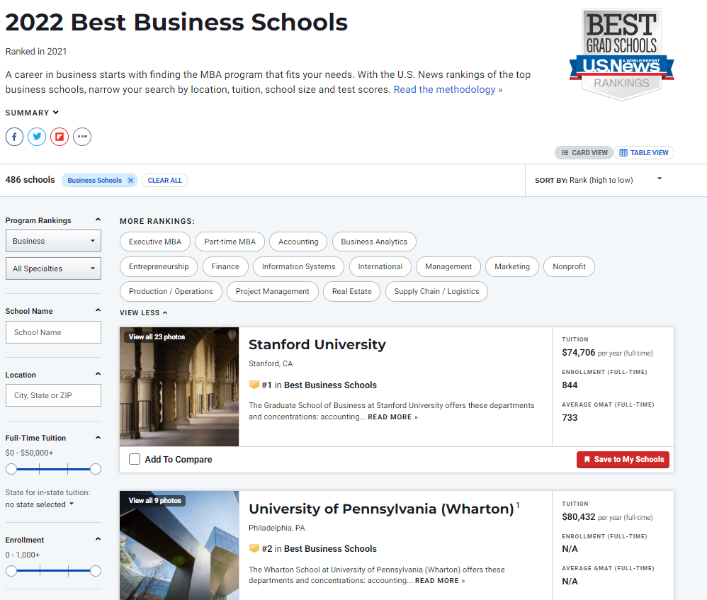

(We bought the premium subscription to get access to all the information for the b-schools)

**1.2 Click top 50 school above and get all the desired information, such as below:**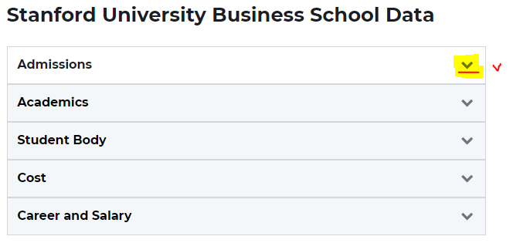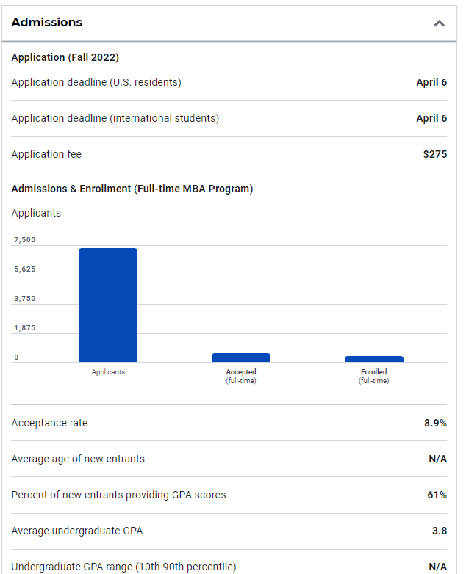

**1.3 Manually typed each school’s data based on website**

For example: Acceptance rate: 8.9%

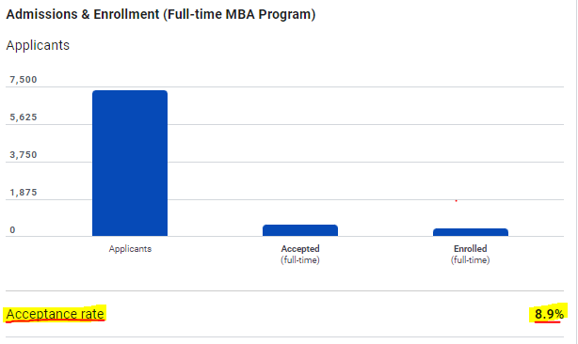

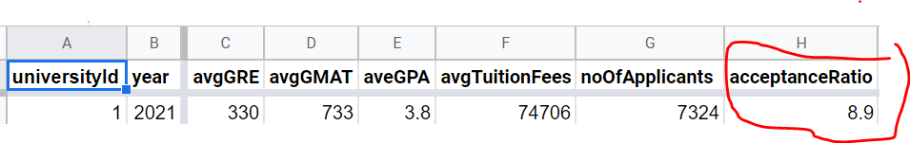

1. **Economist**

**2.1 Search the details for each University:**

<https://whichmba.economist.com/ranking/full-time-mba/2021>

<https://whichmba.economist.com/ranking/full-time-mba/2021/university-of-michigan>

**2.2 Type it into Excel:**

For example, percentageOfFacultyWithPhD



Type above into Excel:

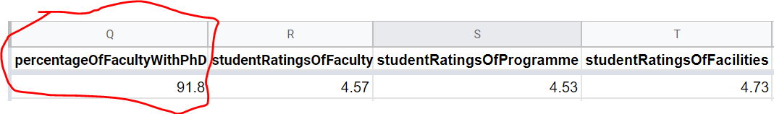

1. **Bloomberg**

**3.1 Search the details for each University:**

<https://www.bloomberg.com/business-schools/regions/us>

**3.2 Type it into Excel:**

For example, Stanford’s compensation/learning/networking

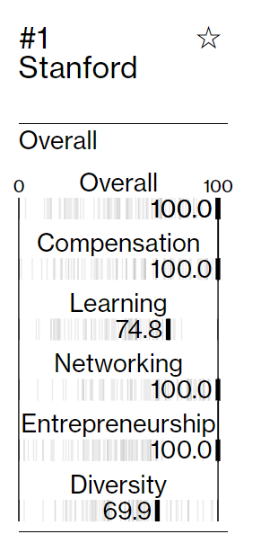



1. **QS Top Universities**

**4.1 Search the details for each University:**

<https://whichmba.economist.com/schools>

Stanford University

<https://www.topuniversities.com/universities/stanford-university>

**4.2 Type it manually into Excel:**

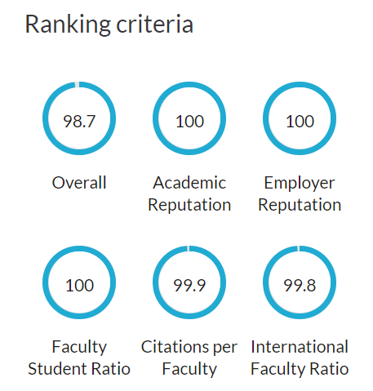



**Final Attributes:**

**US news:**

* avgGRE
* avgGMAT
* aveGPA
* avgTuitionFees
* noOfApplicants
* acceptanceRatio
* avgAge
* avgWorkExperience
* applicationFee
* femalePercentage
* empRateAtGraduation
* empRateAfterThreeMonths
* classSize
* avgOfferedIncome
* addressCity
* addressState
* addressZipCode
* universityName
* contactName
* contactPhone
* departmentName

**The Economist:**

* percentageOfFacultyWithPhD
* studentRatingsOfFaculty
* studentRatingsofProgramme
* studentRatingsofFacilities

**Bloomberg:**

* compensation: Scoring of compensation from BloombergBusinessWeek
* learning:Scoring of Learning from BloombergBusinessWeek
* networking:Scoring of Networking from BloombergBusinessWeek
* entrepreneurship:Scoring of Entrepreneurship from BloombergBusinessWeek
* rank: Best Business school rankings from Bloomberg BusinessWeek

**QS Top Universities:**

* academicReputation,
* employerReputation
* facultyStudentRatio
* citationsPerFaculty
* internationalStudentRatio

**Database Creation in SSMS:**

1. **Installation - Data importing(csv)**

**1.1 Import flat file into MS SQL Server:**

**(We have attached the 4 csv files which we imported with the Suite.)**

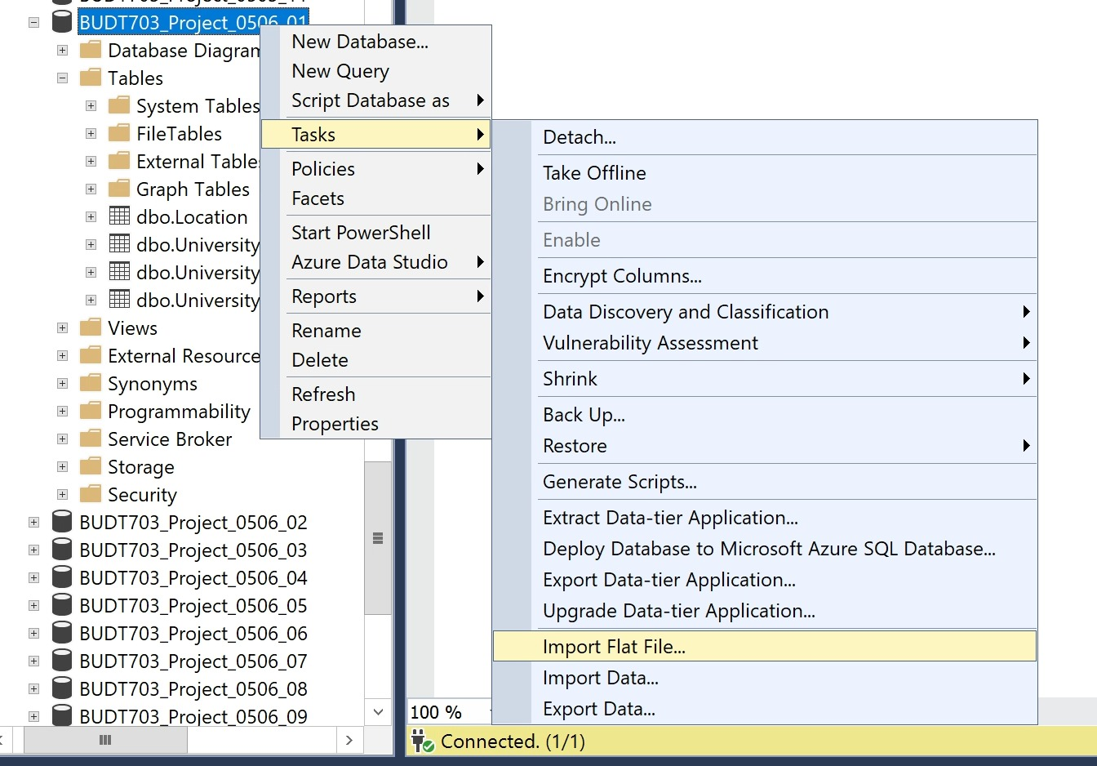

**1.2 Choose the data file:**

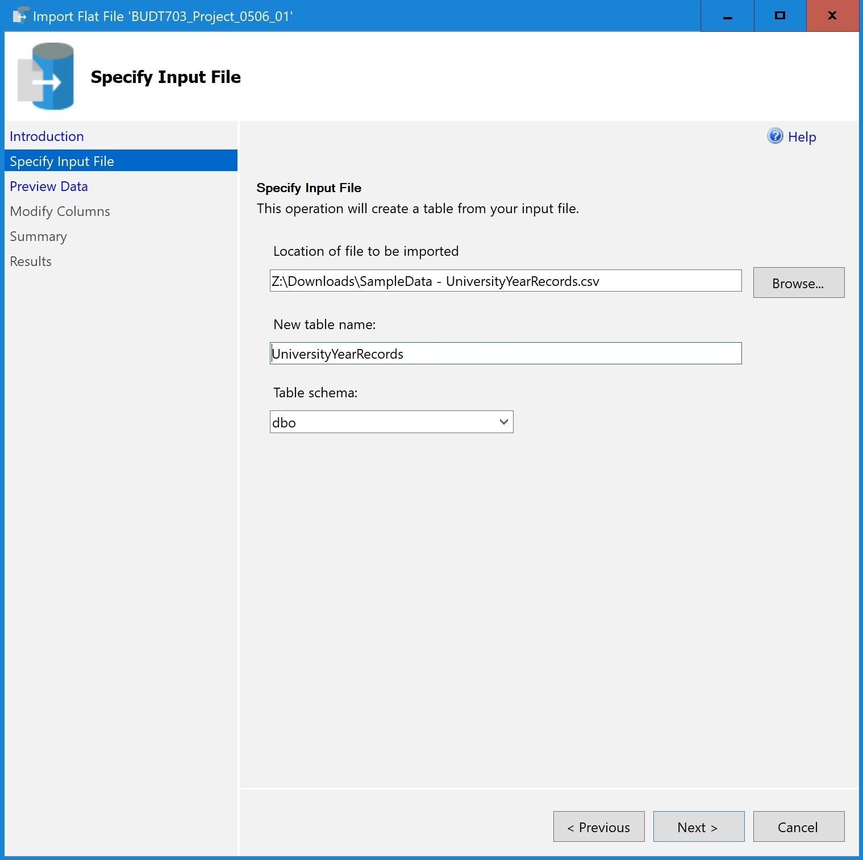

**1.3 Modify data-types:**

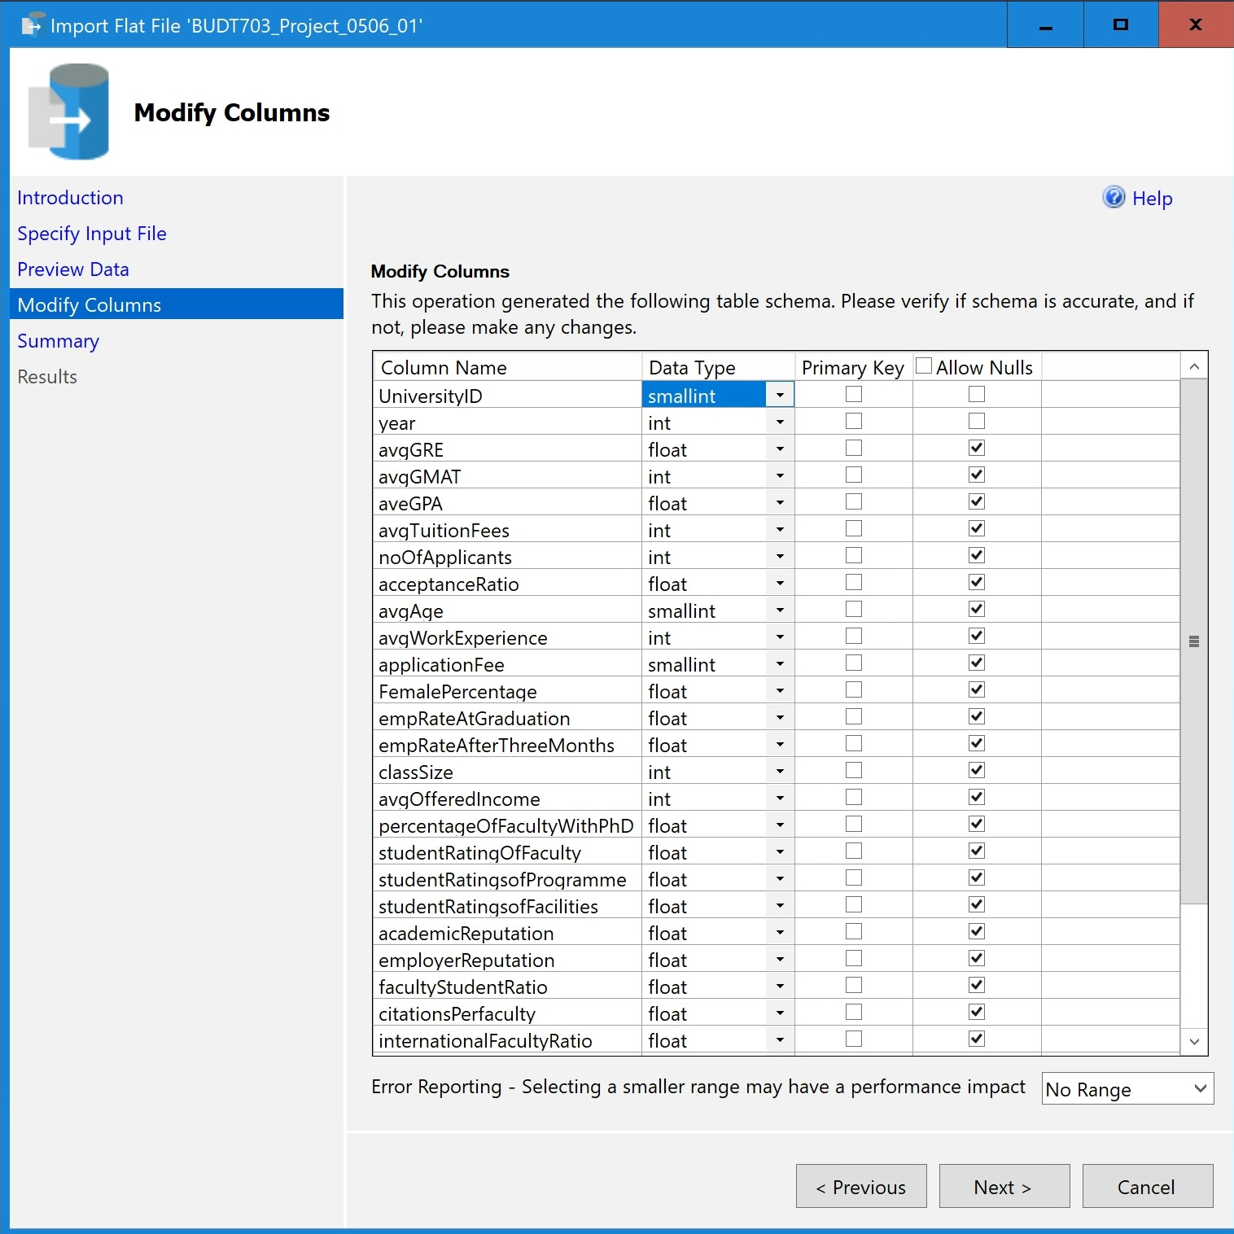

**1.4 Uncheck this option to alter the tables or to add any primary keys:**

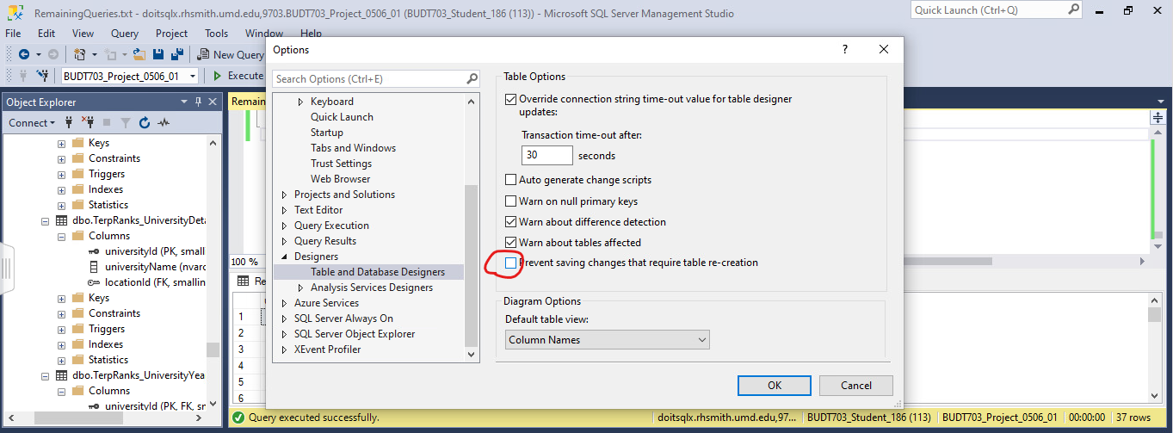

**1.5 Alter Foreign keys:**

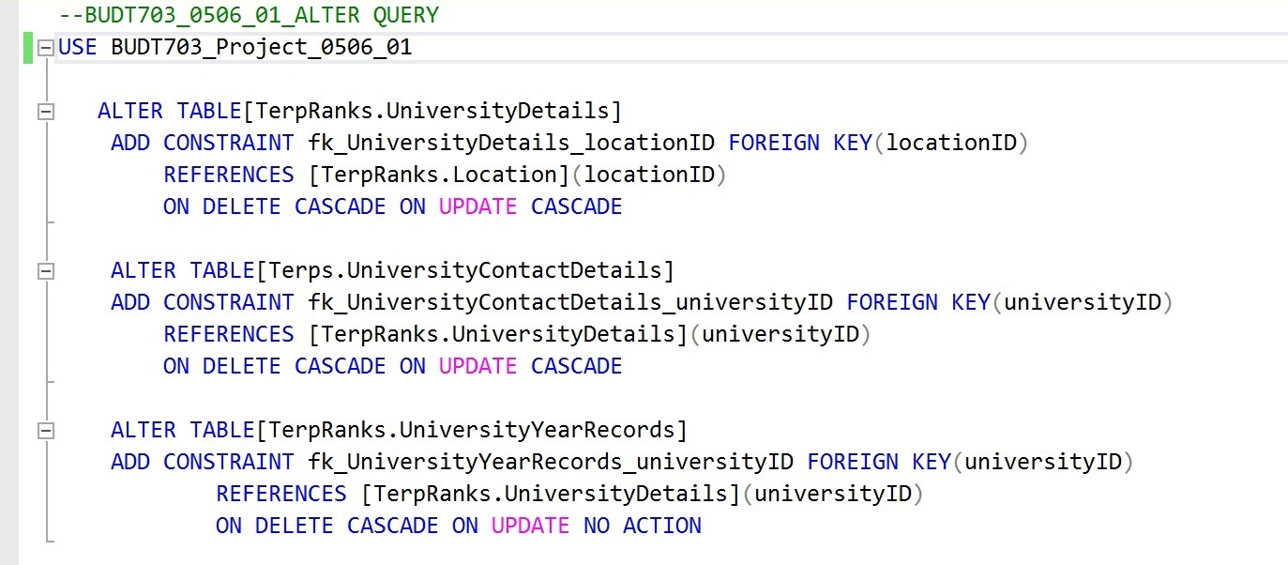

**Results and outputs**

1. **Use Case 1**

Compare admitted students’ average GMAT, GRE scores and GPAs with respect to schools’ employer reputation and rankings

CREATE VIEW [EmployerReputationAnalysis] AS

SELECT d.universityName,y.avgGRE,y.avgGMAT,y.avgGPA, y.employerReputation , y.rank

FROM [TerpRanks_UniversityYearRecords] y, [TerpRanks_UniversityDetails] d

WHERE y.universityId = d.universityId AND y.employerReputation IS NOT NULL

AND y.avgGRE IS NOT NULL

AND y.avgGMAT IS NOT NULL

AND y.avgGPA IS NOT NULL

AND y.avgGPA IS NOT NULL

AND y.Rank IS NOT NULL;

**Application 1**

SELECT TOP 20 universityName,avgGRE,avgGMAT,avgGPA, employerReputation

FROM [Employer_Reputation_Analysis]

ORDER BY rank

**SQL Query Output 1**

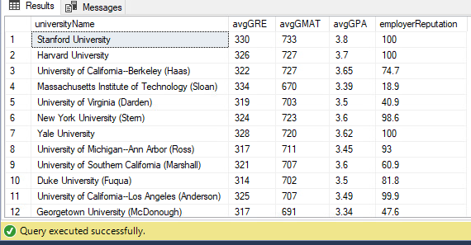

1. **Use Case 2**

Compare admitted students’ GMAT, GRE scores and GPAs with respect to school rankings

CREATE VIEW [AverageScoresBschools] AS

SELECT d.universityName,AVG(y.avgGRE) AS ‘Average_GRE’,AVG(y.avgGMAT) AS ‘Average_GMAT’,AVG(y.avgGPA) AS ‘Average_GPA’, AVG(y.rank) AS ‘Rank’

FROM [TerpRanks_UniversityYearRecords] y, [TerpRanks_UniversityDetails] d

WHERE y.universityId = d.universityId

HAVING AVG(y.avgGRE) IS NOT NULL

AND AVG(y.avgGMAT) IS NOT NULL

AND AVG(y.avgGPA) IS NOT NULL

AND AVG(y.Rank) IS NOT NULL;

**Application 2**

SELECT TOP 10 *

FROM [AverageScoresBschools]

WHERE Average_GMAT > 720

ORDER BY Rank

**SQL Query Output 2**

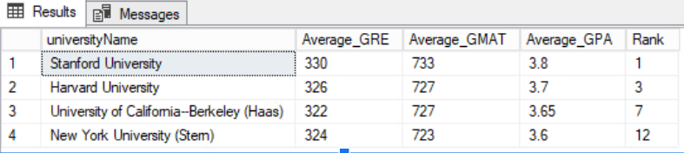

**Business Transactions:**

1. What are the number of applicants for the respective B-school when the application fee is greater than $200?

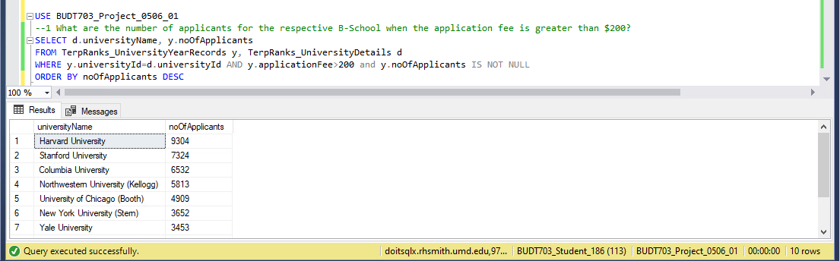

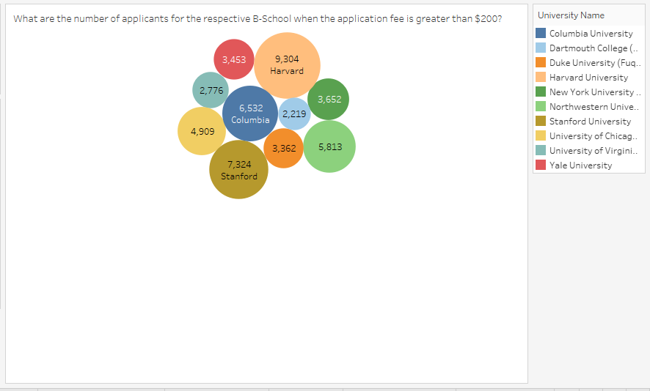

1. What are the number of applicants for the respective B-School when the application fee is less than $200?

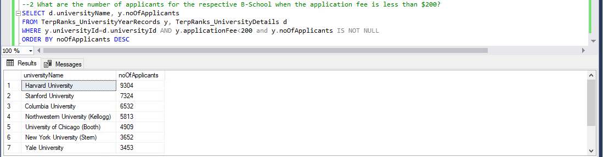

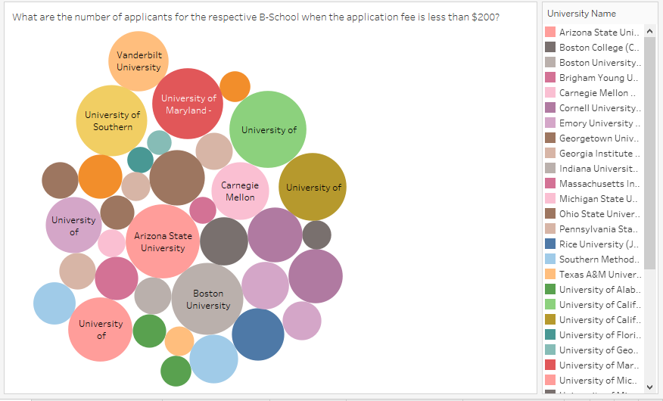

1. What are the rankings of the B-Schools with application fee greater than $200?

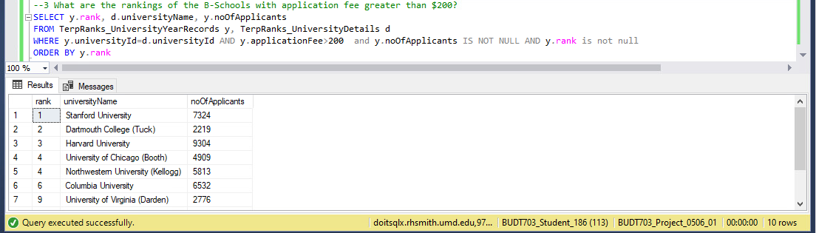

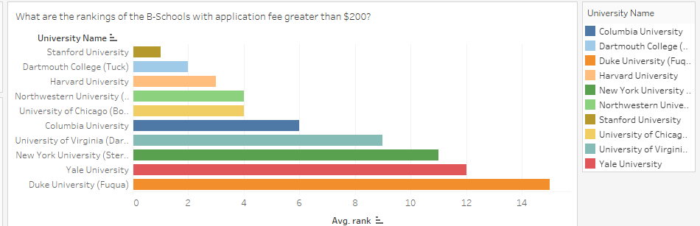

1. As per the students ratings of program content, which ones are the Top-5 B-Schools in the year=2021?

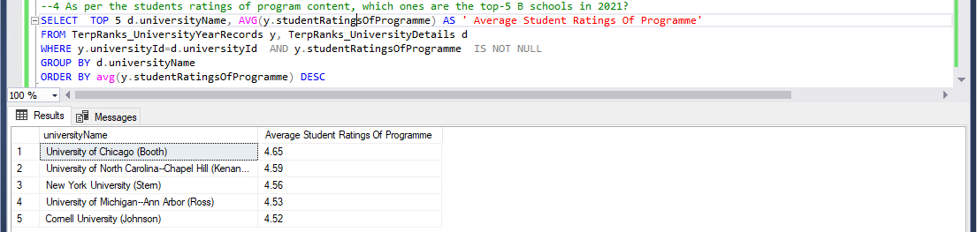

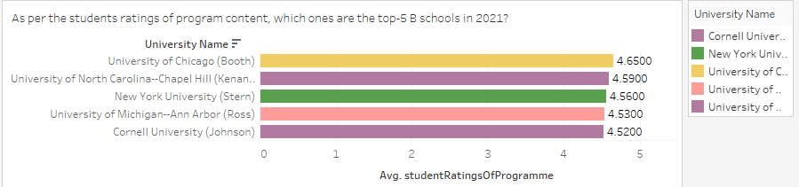

1. What are the Top-5 B-Schools as per the rankings in 2021?

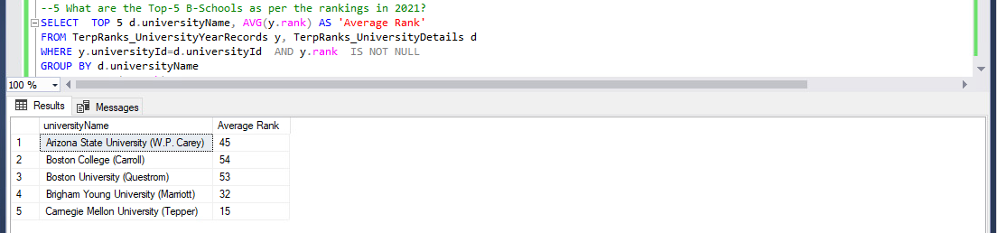

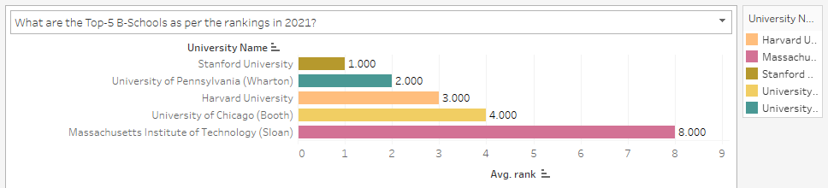

6. As per the employment rate at graduation, which ones are the Top-5 B-Schools in 2021?

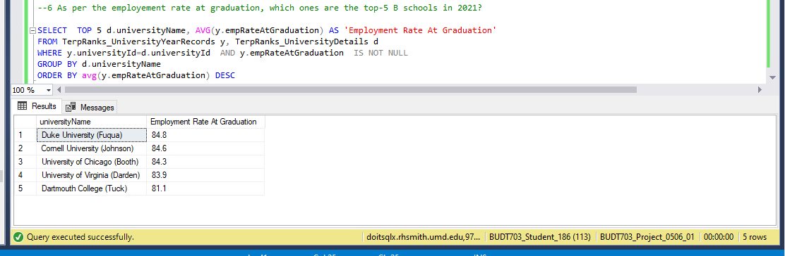

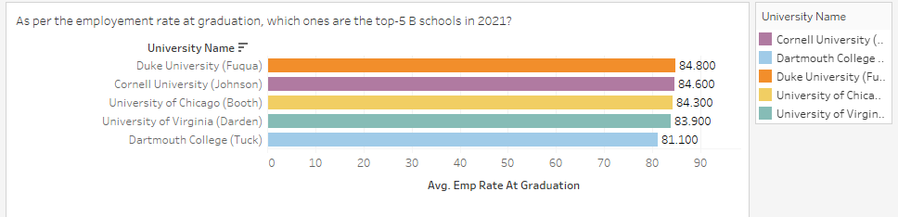

7. As per the students ratings of faculty, which ones are the Top-5 B-Schools in 2021?

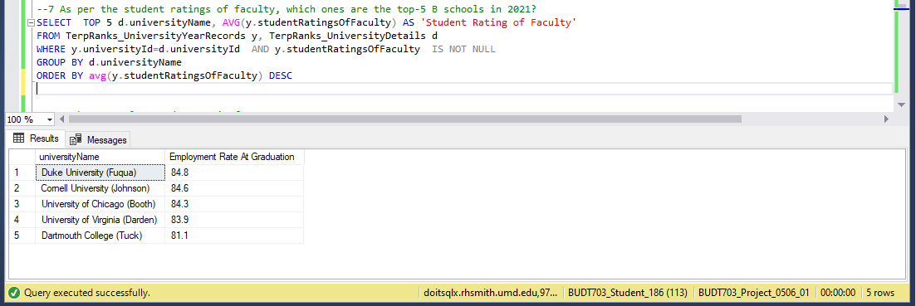

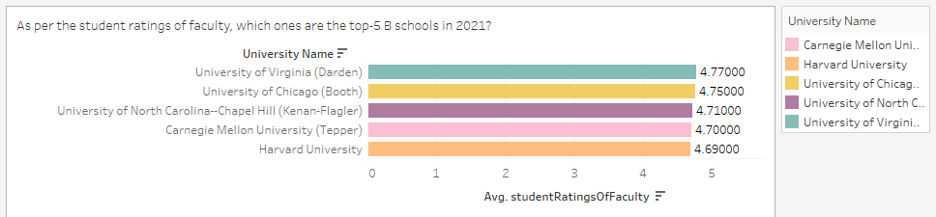

8. What are the school rankings and their respective faculty student ratios for the year 2021?

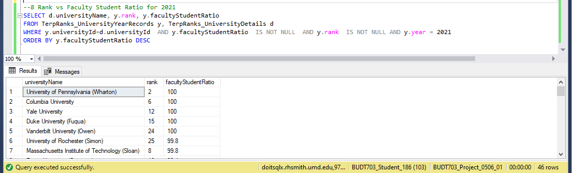

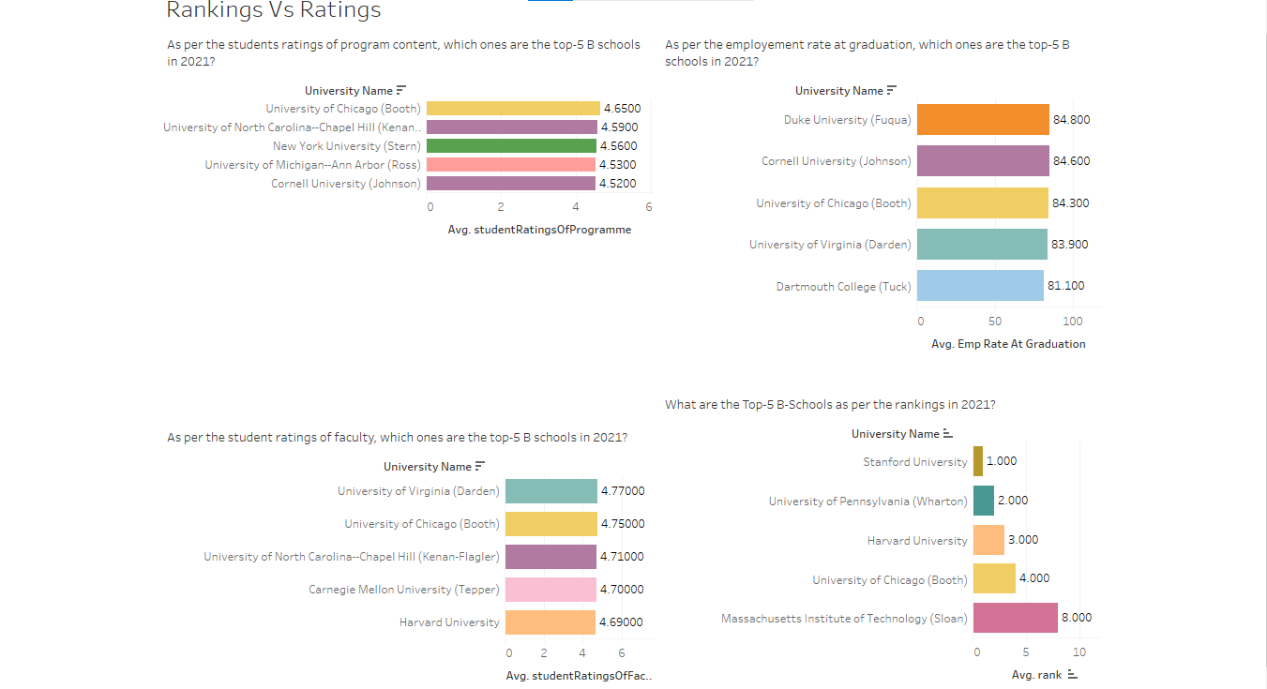

9. What are the school rankings and their respective average GRE score requirements, for the year 2021?

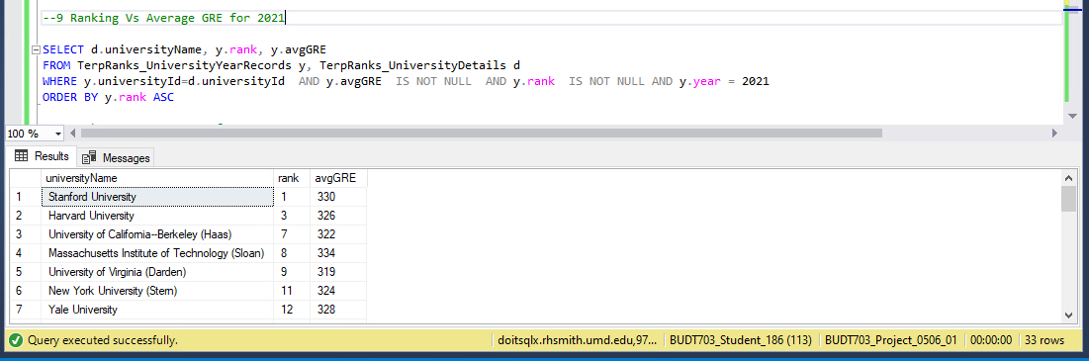

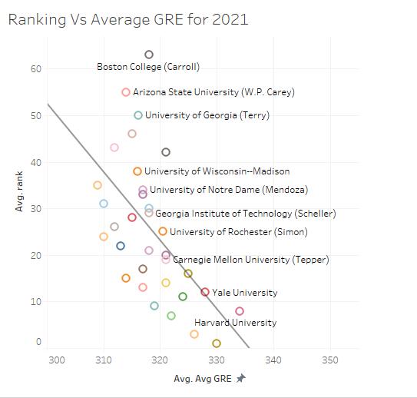

10. What are the school rankings and their respective average GMAT score requirements, for the year 2021?

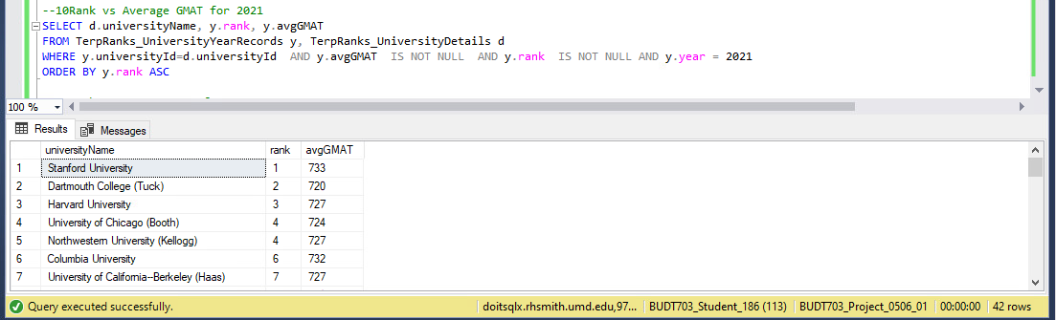

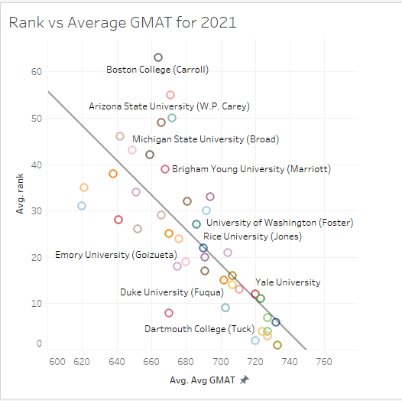

11. What are the school rankings and their respective average GRE score requirements, for the year 2021?

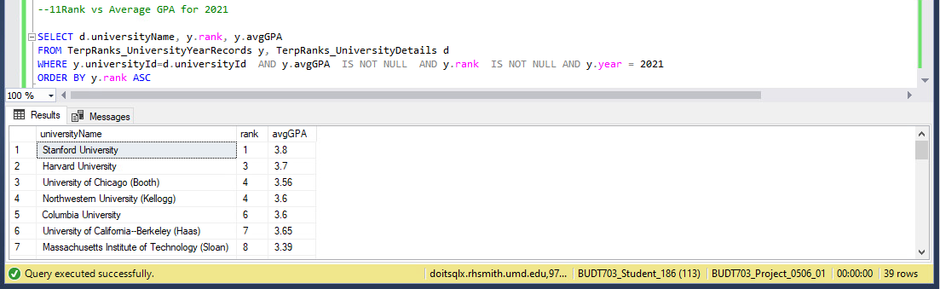

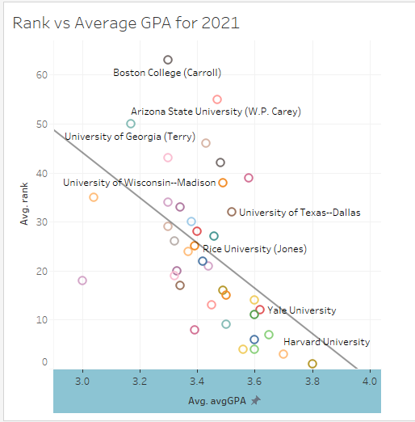

12. What are the school rankings and their respective faculty student ratios for the year 2021?

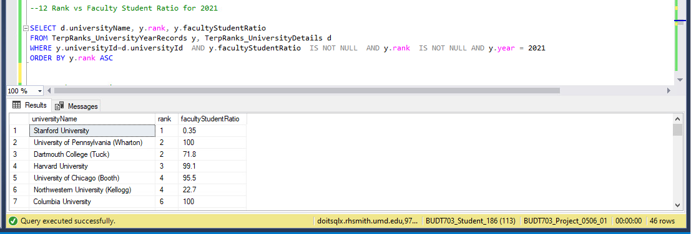

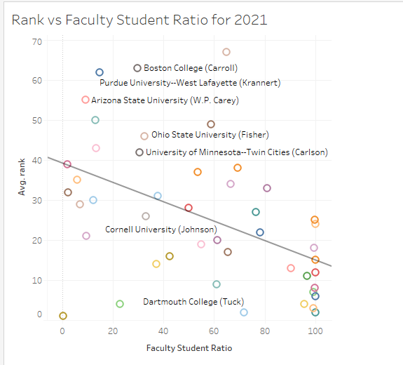

13. What are the school rankings and their respective learning ratings for the year 2021?

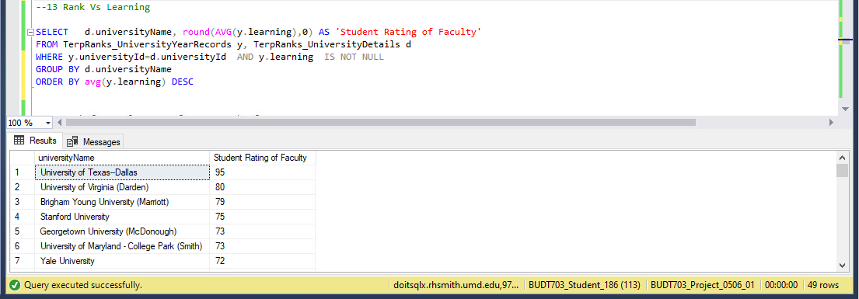

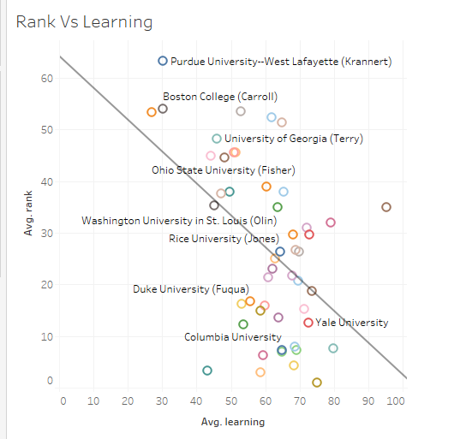

14. What are the school rankings and their respective employment rate after 3 months of graduation for the year 2021?

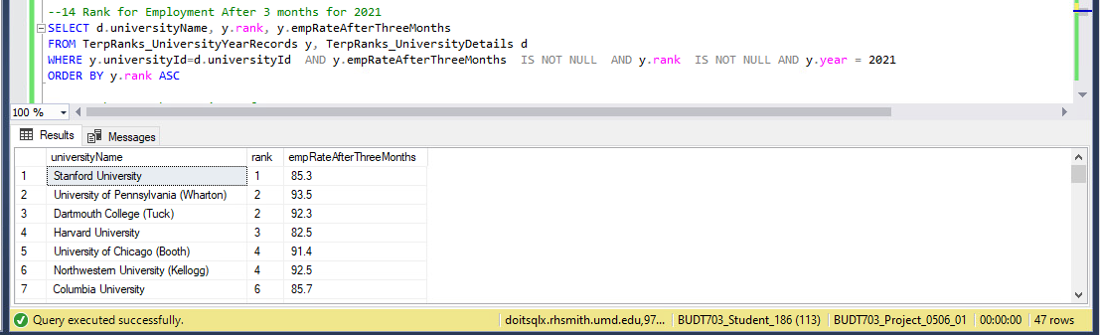

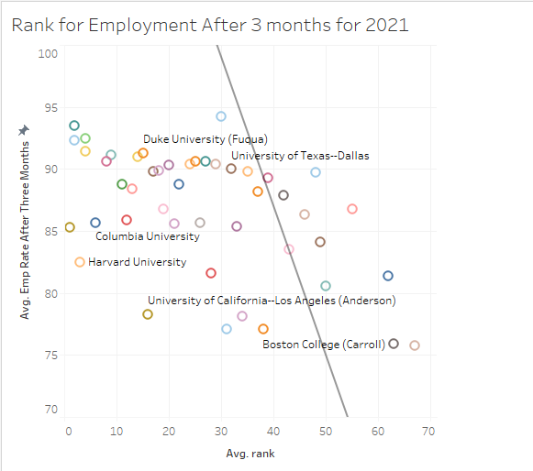

15. What are the school rankings and their respective average work experience for the year 2021?

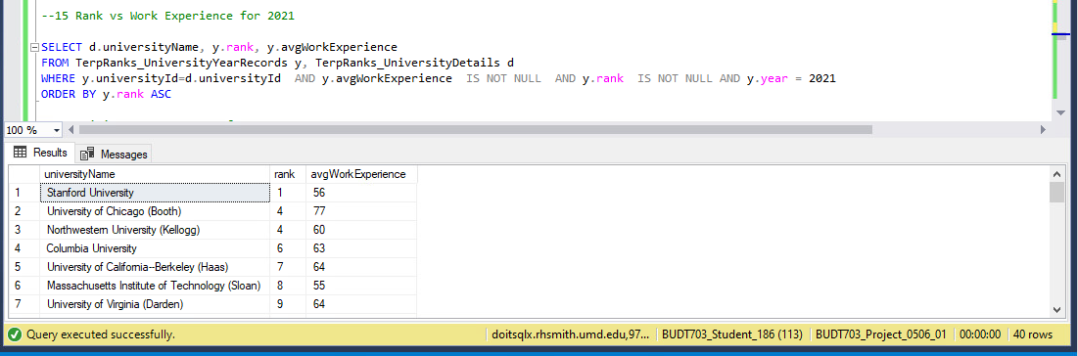

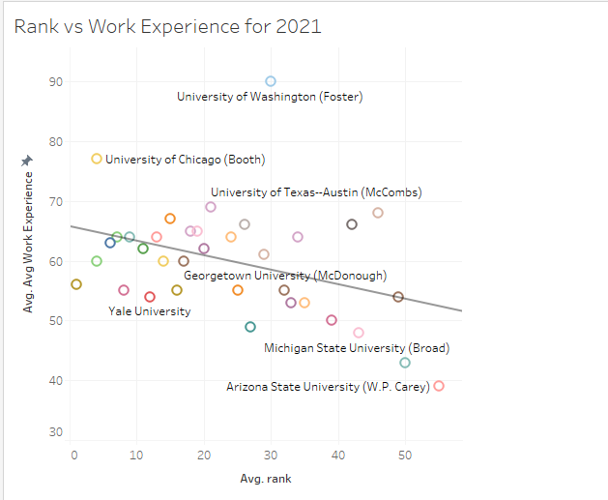

16. What are the average tuition fees and average Offered Income to the students to various B-schools in the year 2021?

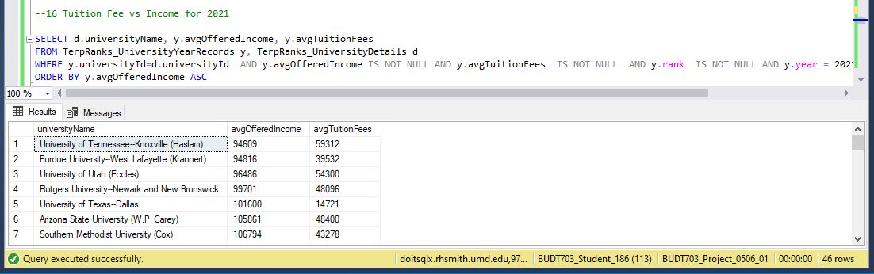

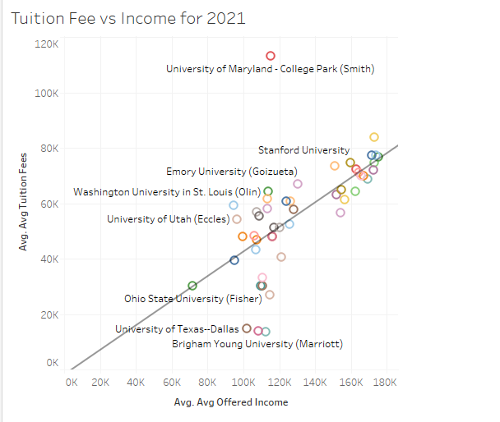

17. Which states have what numbers of Top-30 B-Schools?

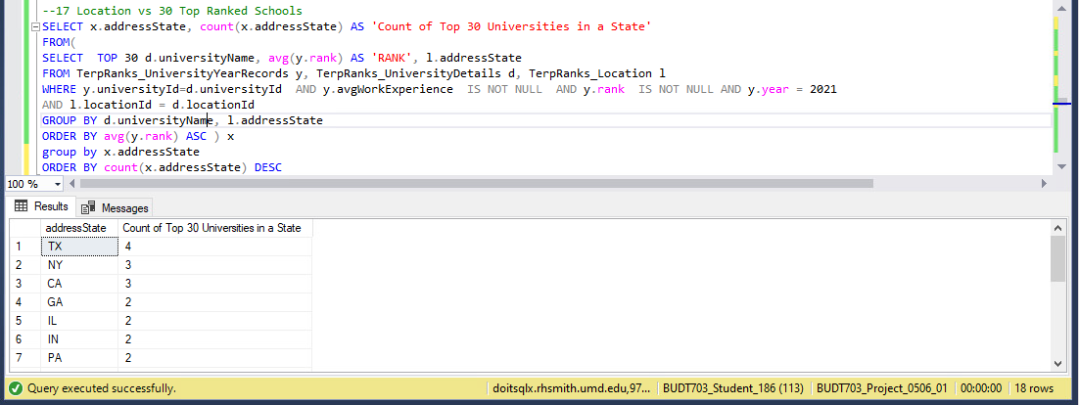

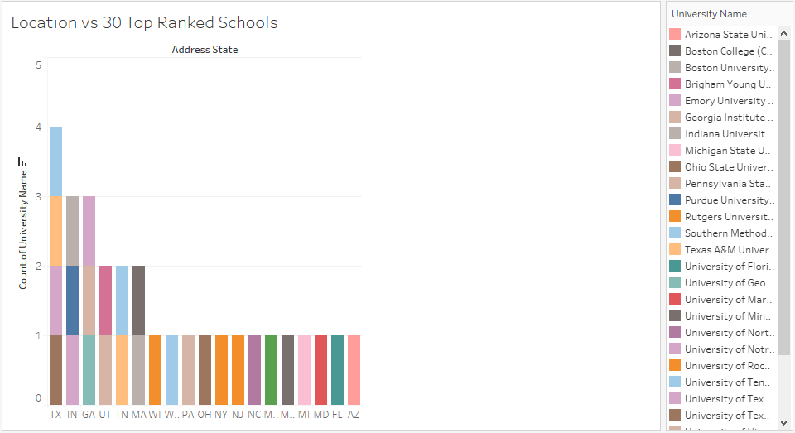

18. What are the school rankings and respective acceptance ratios?

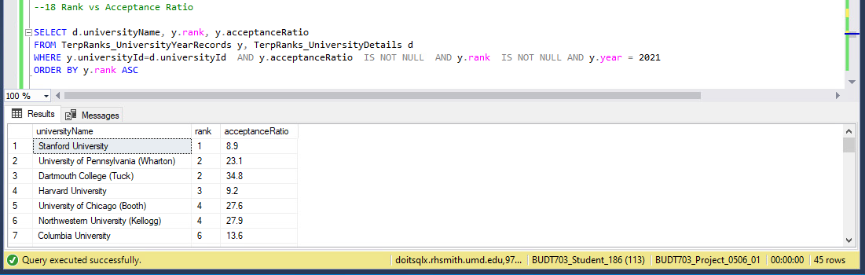

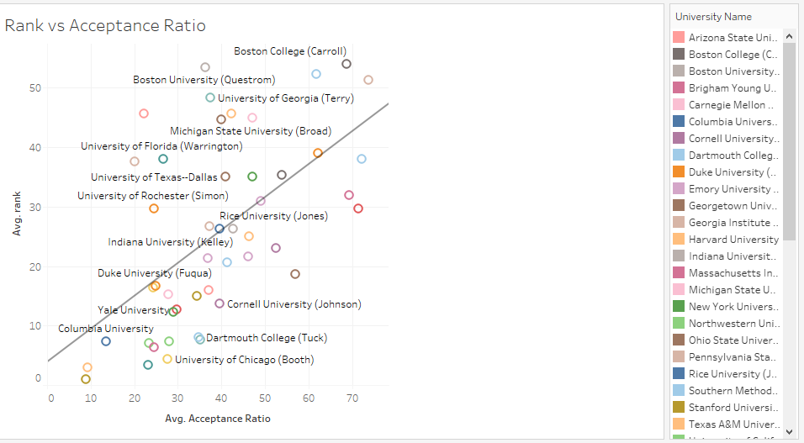

19. What are the school rankings and respective employment reputation rates?

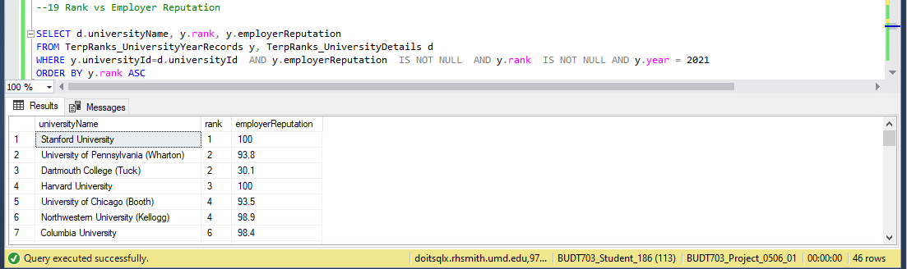

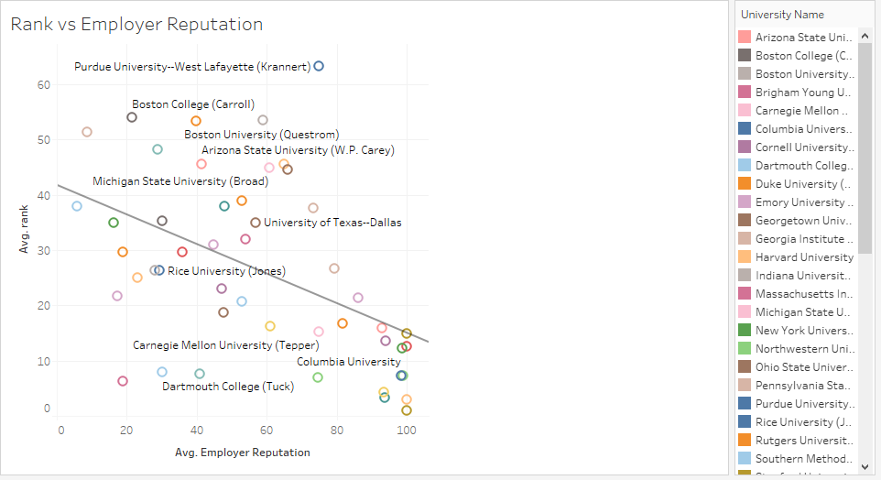

20. What are the school rankings and respective average class size?

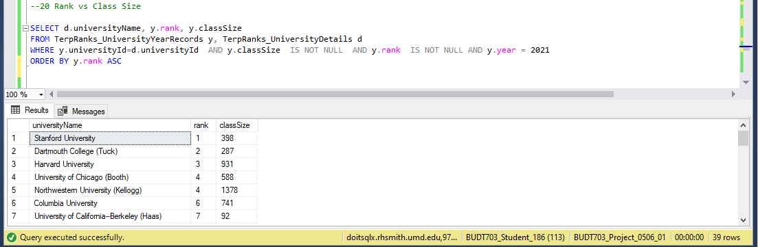

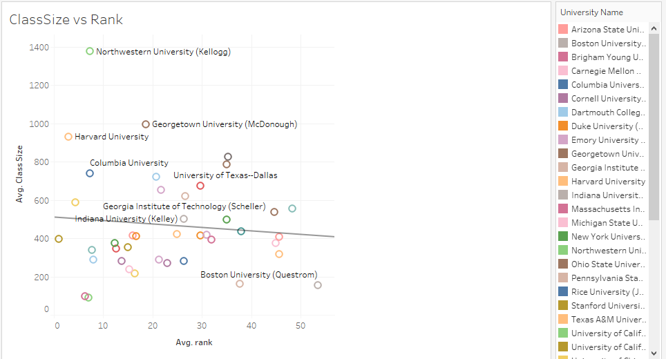

21. What are the school rankings and respective networkings rates?

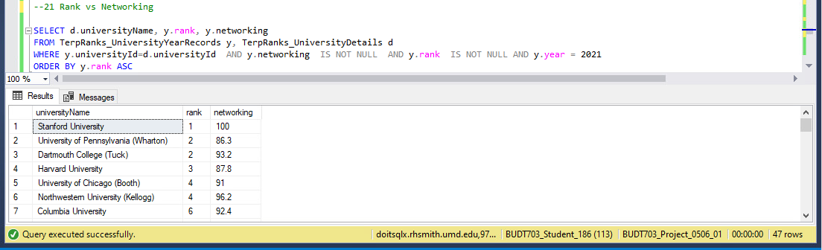

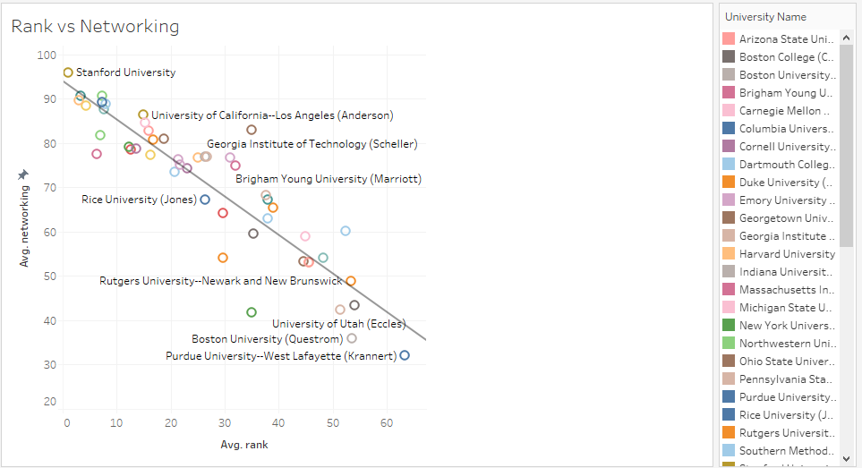

22. What are the school rankings and respective percentage of faculty with PhD degrees?

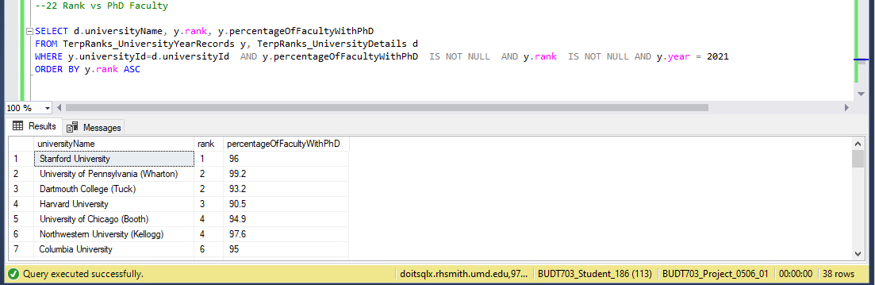

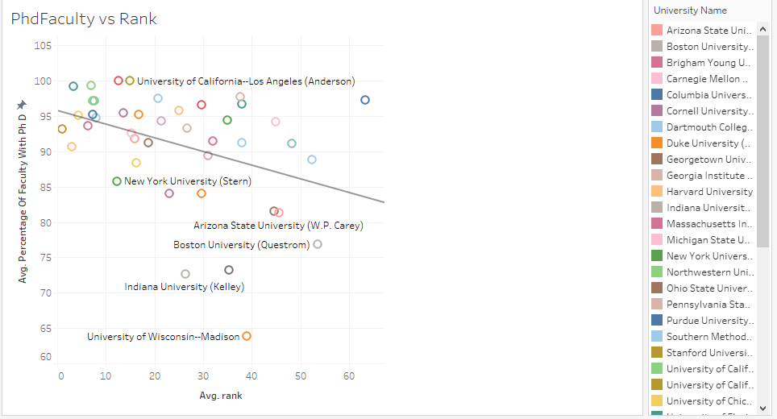

23. What are the school rankings and respective average international student ratio?

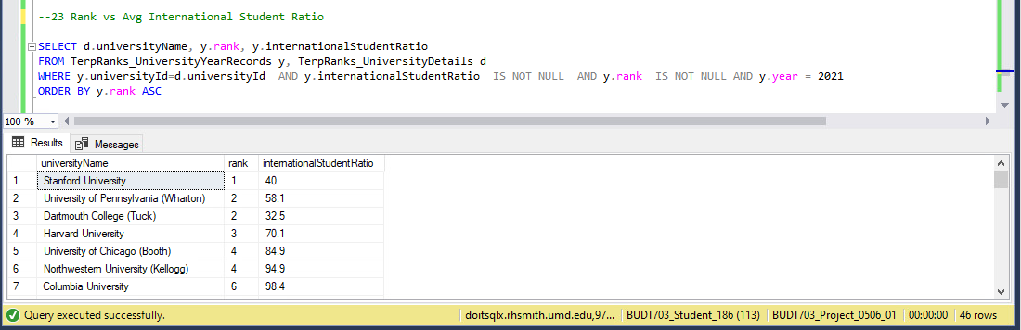

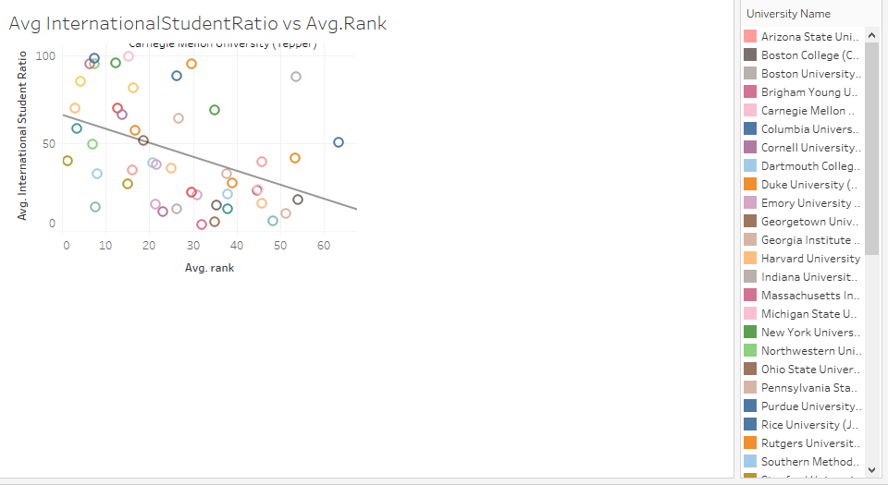

24. What are the school rankings and respective student ratings of program content?

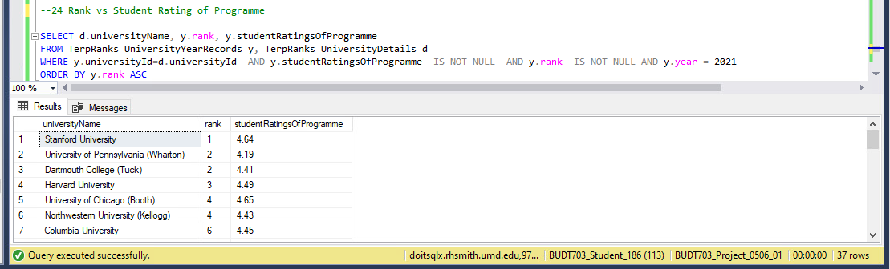

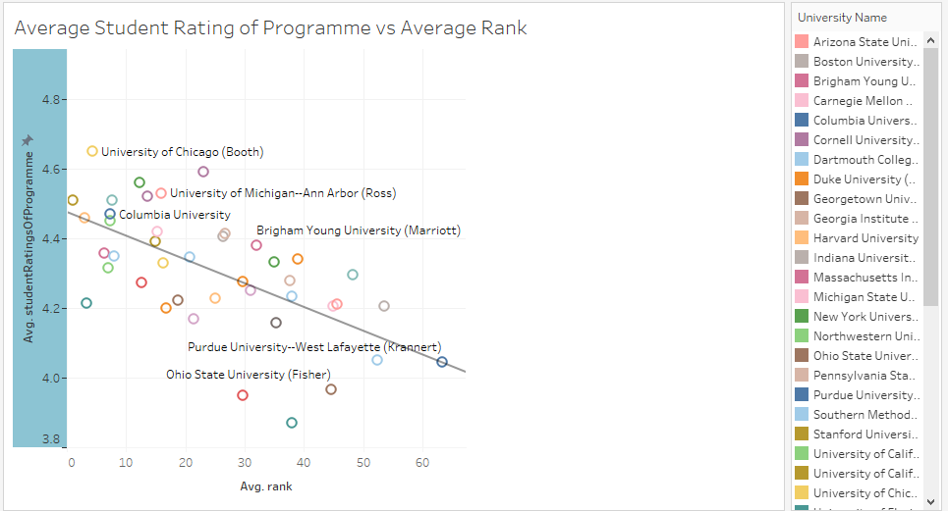

25. What are the school rankings and respective student ratings of facilities?

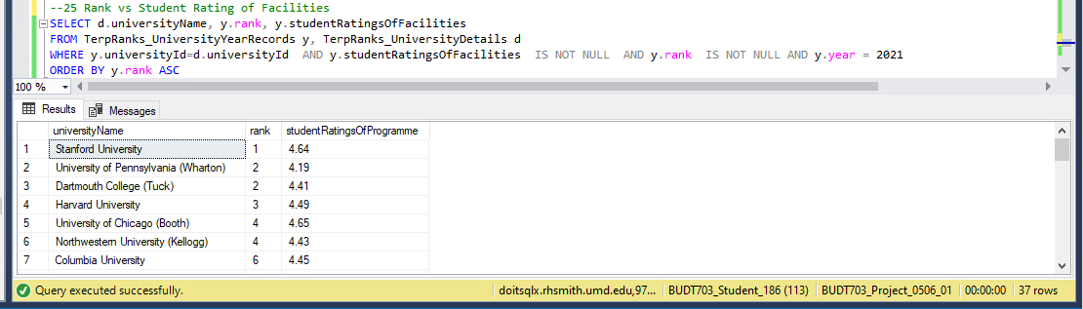

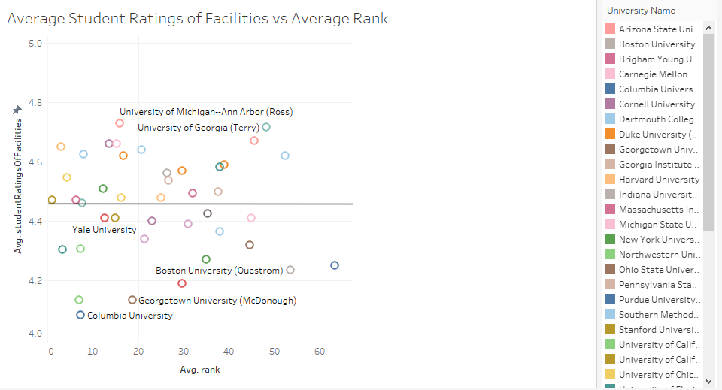

26. What are the school rankings and respective average work experience of the students being admitted?

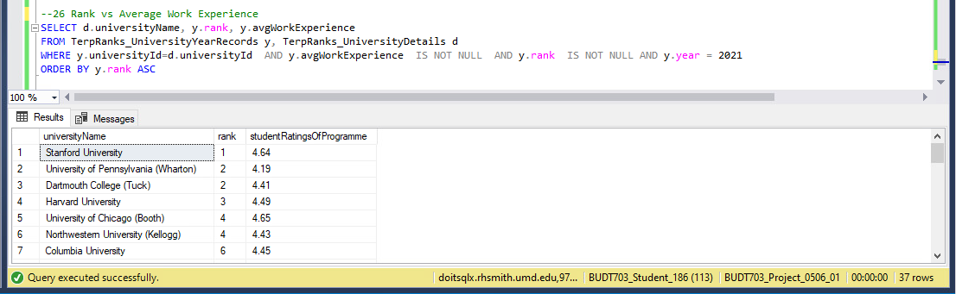

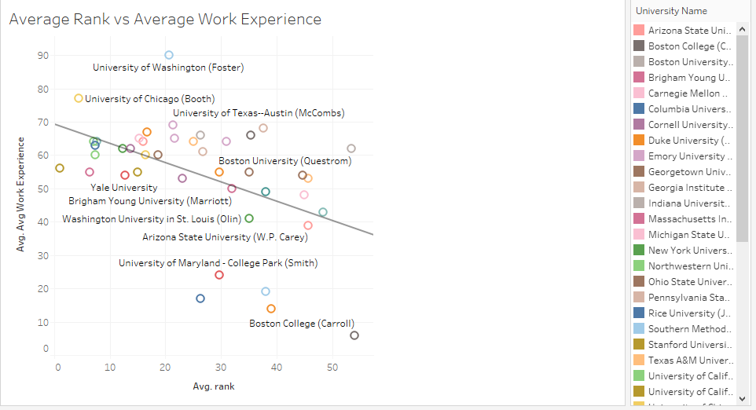

**References :**

1. For importing the CSV into the SSMS we used the below documentation.

<https://docs.microsoft.com/en-us/sql/relational-databases/import-export/import-flat-file-wizard?view=sql-server-ver15>

1. For VIEW statements we used the following website.

<https://www.w3schools.com/sql/sql_view.asp>